

PHYSICS DRAFT SAMPLE EXAMINATION STAGE 3

Section 7 of the WACE Manual: 2008-revised edition outlines the policy on WACE examinations.

Further information about the WACE Examinations policy can be accessed from the Curriculum Council website at
http://newwace.curriculum.wa.edu.au/pages/about_wace_manual.asp

The purpose for providing a sample examination is to provide teachers with an example of how the course will be examined. Further finetuning will be made to this sample in 2008 by the examination panel following consultation with teachers, measurement specialists and advice from the Assessment, Review and Moderation (ARM) panel.

2008/20004




Western Australian Certificate of Education, Draft Sample Examination 2008

Question/Answer Booklet

PHYSICS
WRITTEN PAPER
Please place your student identification label in this box
STAGE 3

Student Number: In figures

In words

Time allowed for this paper
Reading time before commencing work: Ten minutes
Working time for paper: Three hours

Material required/recommended for this paper

To be provided by the supervisor
This Question/Answer Booklet; Formulae and Constants sheet

To be provided by the candidate
Standard items: pens, pencils, eraser or correction fluid, ruler, highlighter

Special items: calculator

Important note to candidates
No other items may be taken into the examination room. It is your responsibility to ensure that you do not have any unauthorised notes or other items of a non-personal nature in the examination room. If you have any unauthorised material with you, hand it to the supervisor before reading any further.

All calculations are to be set out in detail. Marks may be awarded for correct equations and clear setting out, even if you cannot complete the calculation. Express numerical answers to two (2) or three (3) significant figures and include units where appropriate. Express estimates to one (1) or two (2) significant figures, and state any assumptions clearly.
Structure of this paper

Section of exam | Suggested working time | Number of questions | Number of questions to be attempted | Marks available
1 | 60 minutes | 15 | all | 43
2 | 80 minutes | 6 | all | 65
3 | 40 minutes | 2 | all | 28
overall |  |  |  | 4
 |  |  | [Total mark] | 140

Note: the ‘overall’ section represents marks allocated to appropriate use of units and significant digits in final answers to numerical problems.

Instructions to candidates

1. The rules for the conduct of Curriculum Council examinations are detailed in the Student Information Handbook. Sitting this examination implies that you agree to abide by these rules.

2. Answer all questions in the spaces provided in this Question/Answer Booklet.

3. A blue or black ballpoint or ink pen should be used.
SECTION ONE: SHORT ANSWER

This section has FIFTEEN (15) questions. Answer all questions in the spaces provided.

Suggested working time: 60 minutes [43 marks].

Question 1
Consider the two spectra A and B below. One of them is the spectrum of red laser light and the other is the spectrum of torchlight after it has passed through transparent red plastic.
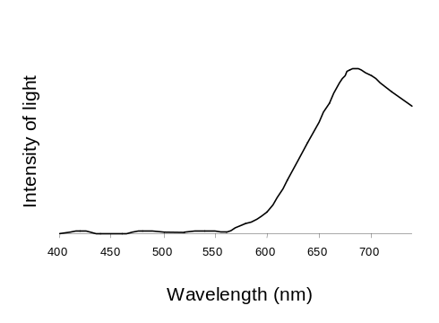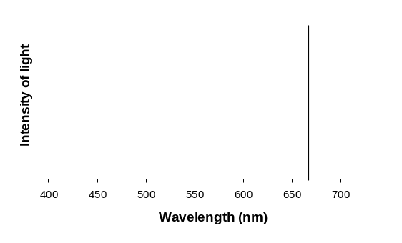
A B

Indicate which spectrum is associated with which light source, and give a reason for each one.
[1 mark]

A is the spectrum of ______________ and B is the spectrum of ________________

Reason:
[1 mark]

Question 2
Mount Everest is 8.85 km high. The acceleration due to gravity on the top of Mount Everest is:

- about the same as at sea level.
- about 10% less than at sea level.
- much less than at sea level. Answer
[1 mark]

Explain how you arrived at your answer.
[2 marks]

Question 3
Quasars are small but very luminous astronomical objects. Most quasars have very large redshifts. This is interpreted as evidence that quasars must have existed long ago, and were thus a feature of the early history of the Universe. Explain the connection between large redshift and the apparent great age of quasars.
[2 marks]

Question 4
Consider the following picture of two screwdrivers, labelled P and Q. Which is the better one to use to loosen a screw that is particularly tight?

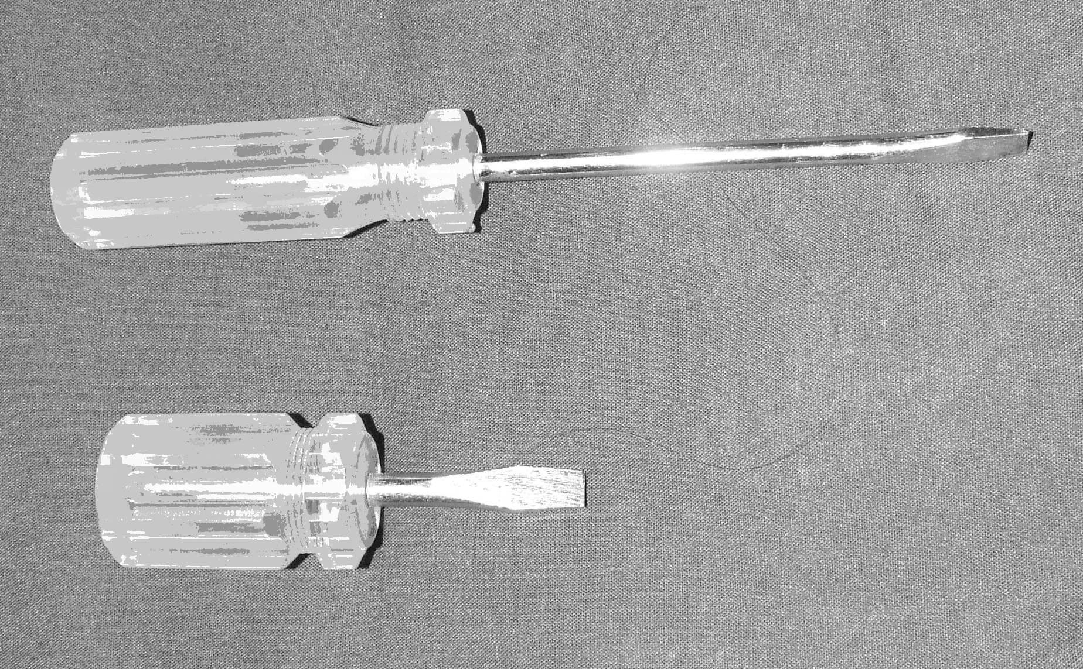
Q
P

Answer _______________

Explain your answer.
[1 mark]

Question 5
In July 1969, the Apollo 11 command module orbited the Moon while waiting for the return of the ascent module containing the two astronauts who had landed on the Moon’s surface. The mass of the command module was 9.98 x 10³ kg, its period was 119 minutes, and the radius of its orbit from the Moon’s centre was 1.85 x 10⁶ m.

Assuming the command module was in circular orbit, show all working used to calculate:

- the magnitude of the orbital velocity of the command module.
[2 marks]

- the mass of the Moon.
[2 marks]

Question 6
A wire carrying an electric current is placed between the poles of a horseshoe magnet. The current is going into the page.

N
S

- Show on the diagram the direction of the force on the wire.
[1 mark]
- Sketch on the diagram the net magnetic field.
[1 mark]
Question 7
Assume that the Earth’s magnetic field is horizontal and has a magnitude of 55 μT. You are given the rim from a bicycle wheel.

- Describe how you would have to hold the wheel in order for the maximum amount of magnetic flux to pass through it.
[2 marks]

- Estimate this maximum amount of magnetic flux passing through the wheel.
[3 marks]

Question 8
Police handheld radar guns emit pulses of microwave radiation. If the frequency of the radiation is 3.3 x 10⁹ Hz and the pulse duration is 0.10 μs, how many waves does one pulse contain?
[2 marks]

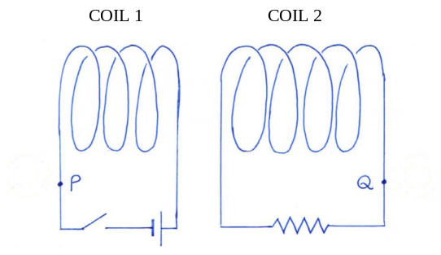
Question 9
The diagram at right shows two separated wire coils.

- At the instant the switch is closed, a (conventional) current begins to flow in Coil 1. At the points P and Q draw arrows to show the direction of the (conventional) current I₁ in the circuit for Coil 1 and the direction of the induced (conventional) current I₂ in the circuit for Coil 2.
[2 marks]

- If the switch remains closed, what happens to the current in Coil 2? Circle your choice of the options given below.
[1 mark]

It reverses It decreases to zero It remains unchanged

Question 10
A springboard diver with a mass of 62.5 kg is standing on the end of a diving board as shown below. The springboard has a mass of 120 kg. A clamp at C holds the end of the board in place.
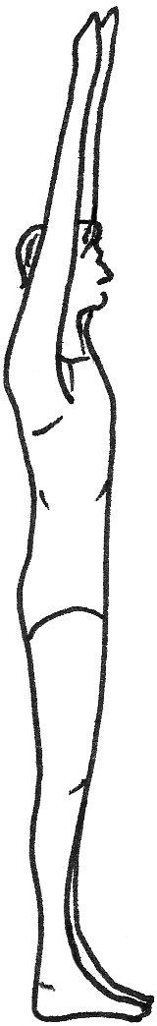
C
P
4.00 m
1.20 m

Assume that the springboard is uniform and rigid (does not bend).

- On the diagram, use arrows to show the direction of the forces on the board due to the pivot point (P) and the clamp (C).
[2 marks]

- Calculate the magnitudes of the forces acting on the clamp (C) and the pivot point (P) when the diver is standing on the end of the board.
[2 marks]

Question 11
The diagram below shows a uniform magnetic field directed into the page. Three particles P, Q and R have masses and charges as shown in the table. They each enter the magnetic field with the same velocity, v, as shown. Complete the diagram to show the paths of particles Q and R. The path of particle P has been already been drawn.
Particle | Relative charge | Relative mass
P | 1 + | m
Q | 2 + | 2 m
R | 1 − | 2 m
[3 marks]
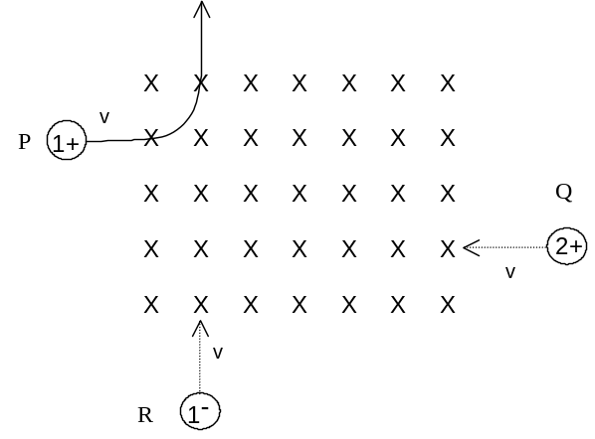

Question 12
The diagram below shows how a mass and pulley system can be used in hospitals to keep an injured leg under tension. Calculate the tension in the leg, and include a free body diagram showing all forces acting on the leg.
[3 marks]
[Diagram from: Giancoli, 1995]

For copyright reasons this image cannot be reproduced in the online version of this document.

Question 13
On the way back to Earth from the Moon, a spaceship passes through the point where the gravitational acceleration toward the Earth is equal to the gravitational acceleration toward the Moon. Calculate the percentage of the return distance for this point?

Hint: In determining a solution to this problem, you might find the following relationships useful:
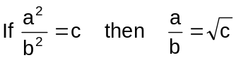

Moon
Earth

[3 marks]

Question 14
It is possible to arrange an electric field and a magnetic field in a single region of space, such that they exert equal but opposite forces on a charged particle travelling through that region.
Show that the force cancellation can only occur at a particular value of velocity for a given electric field strength and magnetic field strength.
[3 marks]

Question 15
Beta decay of a light nucleus such as 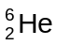 can be observed in a device that shows the tracks of the charged particles produced by the event. The diagram below shows a record of such a decay. The more massive product nucleus produces a short, thick track and the less massive beta particle produces a longer, thinner track. Such recordings provide evidence that ‘antineutrinos’ are also produced during the decay process. This event can also be represented by an equation in which the antineutrino is shown as :
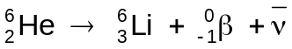
Track of recoiling 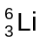nucleus
Track of recoiling beta particle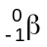

Explain how the diagram shown above suggests the existence of the antineutrino particle.
Hint: momentum must be conserved in both the x and the y directions.
[2 marks]

END OF SECTION ONE

SECTION TWO: PROBLEM-SOLVING

This section has SIX (6) questions. Answer all questions in the spaces provided.

Suggested working time: 80 minutes [64 marks].

Question 16
While on vacation, Brigette visited a European castle. It was a windy day, and she could hear a sound coming from the fireplace (no fire was burning in the fireplace). She concluded that the wind was generating a standing wave of frequency 30 Hz in the chimney, which was acting as a pipe open at both ends.
- Draw labelled sketches of the fundamental and next possible harmonic of the standing wave that could exist in the chimney. Justify the shapes you have decided to draw.
[4 marks]

- Assuming that the sound Brigette heard was due to the fundamental standing wave, estimate the length of the chimney.
[4 marks]

Question 17
- The emission spectrum of hydrogen looks like this:

The energy level diagram below is for the hydrogen atom.
E₁
E₄
E₅
E₃
E₂
n=5
n=4
n=3
n=2
n=1

- Draw on the above energy level diagram all transitions that can contribute to the emission spectrum. Assume that the atom is in the n = 4 energy state.
[2 marks]

- The transition between levels 1 and 3 results in a photon of wavelength 102.6 nm. Calculate the change in energy between levels 1 and 3.
[2 marks]

- A particular protein in jellyfish glows with a visible colour when viewed under ultraviolet light. Scientists have managed to extract this protein, called GFP, and incorporate it into the DNA of micro-organisms as well as larger animals. One such animal is a white rabbit, which appears coloured under UV light.

- Name the physical phenomenon which is occurring here.
[1 mark]

- Describe how it occurs.
[3 marks]

- Use the following diagram (and any other information in Question 17) to predict the colour of the ‘GFP rabbit’. Explain your reasoning carefully.
[2 marks]
[Diagram from: Walker, 2004]

For copyright reasons this graph cannot be reproduced in the online version of this document.

THIS SECTION HAS BEEN LEFT BLANK INTENTIONALLY

Question 18
A simple single-phase generator has a coil of 200 turns. The coil is 14 cm long and 9 cm wide. The magnetic field in the generator is 0.15 T. The generator coil is turned at a rate of 3000 revolutions per minute.

- With the aid of the diagram, briefly explain the purpose of the slip rings on a generator.
[1 mark]
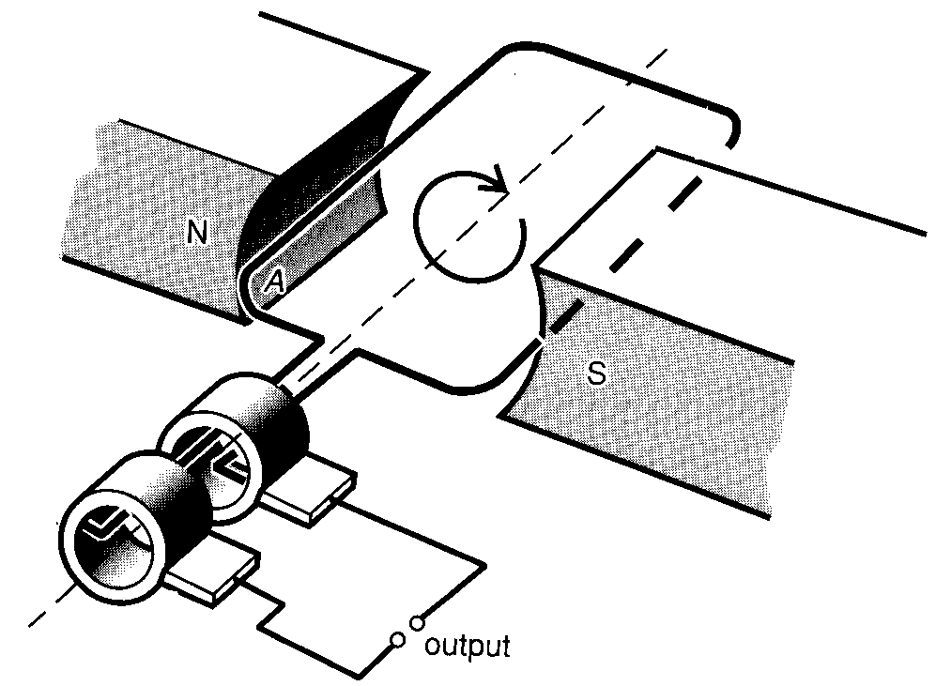

- (i) On the following axes, draw a graph of the emf generated by this device. Show the scales on the axes.
[2 marks]

t
emf

(ii) On the following axes, draw a graph of the emf produced if the generator were turned at 6000 revolutions per minute instead of 3000 revolutions per minute. Show the scales on the axes.
[2 marks]
t
emf

- (i) Calculate the emf produced by this generator.
[3 marks]

(ii) Is the emf you calculated the maximum emf produced, or the average emf produced?
[1 mark]

- State two ways in which the construction of this generator could be modified in order to increase the emf generated. In each case, state the reason for your answer.
[4 marks]

Question 19
Cyclotrons are used to accelerate charged particles to high speeds. In a cyclotron, charged particles are placed in a magnetic field so that they travel in a circle. For a particular cyclotron, the magnetic field is 0.35 T, and protons of kinetic energy 0.23 MeV are being produced.

- (i) The protons hit a target. If all the energy of one proton is converted into a single photon of electromagnetic radiation, calculate the wavelength of the radiation.
[2 marks]

(ii) In which region of the electromagnetic spectrum is this radiation?
[1 mark]

- Could the radiation emitted when the protons hit the target be used to inspect welds for cracks? Explain, using appropriate physical principles.
[3 marks]

- (i) Calculate the radius of the circle travelled by the protons.
[3 marks]

(ii) What would happen to the radius of the circle if the proton energy were increased? Give the reason for your answer.
[2 marks]

THIS SECTION HAS BEEN LEFT BLANK INTENTIONALLY

Question 20
- Calculate the maximum possible height (h) and horizontal range (R) for a stream of water from a fire hose if it is directed at a speed of 40.0 m s⁻¹ and at a launch angle of 60° above the horizontal.
[3 marks]

h

R
60.0°

- Helicopters are often used to drop water onto small bush fires. A helicopter approaching a bushfire at a speed of 22 m s⁻¹ must release the water no closer than 150 m horizontally from the fire and then turn quickly away to avoid flying over the fire. Calculate the minimum height that this helicopter can fly at this speed to ensure that the water reaches the fire.
[3 marks]

- When fighting fires in some buildings, there is a limit to how close fire-fighters can get to the fire. For the fire illustrated below, the fire-fighter cannot stand closer than 40 m from the building. The best trajectory for the water for this roof fire is when it reaches its maximum height just before it drops down onto the fire (as shown below).
θ
40 m
32 m

- The graphs below show the theoretical maximum height and range for water fired from a hose at different angles above the horizontal and with three different velocities (20, 30 and 40 m s⁻¹). On each graph, circle the point that corresponds to the maximum height and range for a launch angle of 60.0° and launch speed of 40.0 m s⁻¹.
[2 marks]

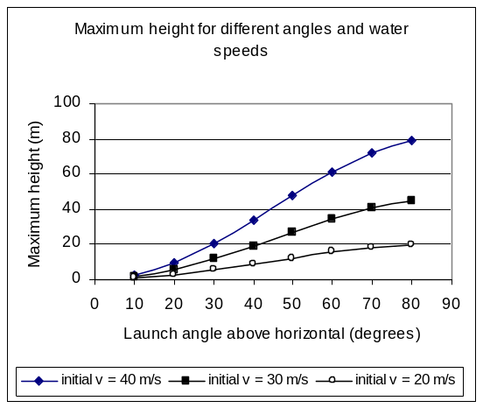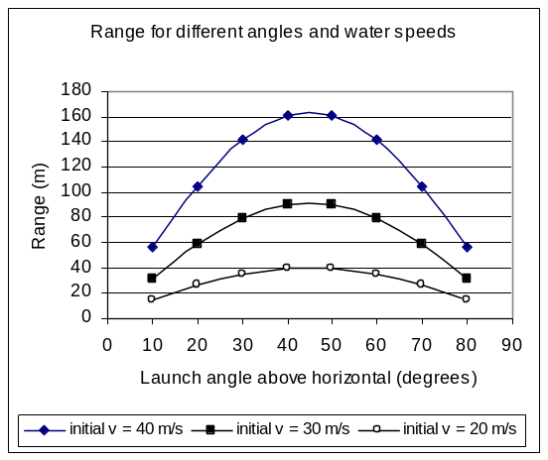

- For the fire-fighting situation described above, where the fire-fighter wants the water to land on the fire from a few metres above it, estimate the best combination of launch angle (θ) and water velocity. Ignore air resistance. Give the angle to the nearest 10° and speed to the nearest 10 m s⁻¹. Briefly explain your choice.
[2 marks]

Best angle = Best velocity =

Explanation:

Question 21
An observer stood to one side of a beam of particles, each having charge –Q and moving in a straight line with a velocity v as shown. A length l of this beam contained n particles.

v
Observer

- (i) Determine how far any one particle travelled in a time T, in terms of the given variables.
[1 mark]

(ii) Determine the number of particles which passed the observer in a time T, in terms of the given variables.
[2 marks]

- This beam could be considered to be an electric current. Show that the magnitude of the current, I, flowing as a result of this beam could be determined using the expression
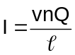
Hint: Your answers to (a) above may help you to answer (b).
[3 marks]

- The observer then turned on a uniform electric field, having field strength E and directed across the beam, from left to right and at right angles to the velocity v as shown in the diagram below.
v
Observer
E

- Use a solid arrow () to show the direction of this electric force on one charged particle in the diagram above.
[1 mark]
- Use a dashed arrow () to show the resulting path of this charged particle.
[1 mark]

- (i) Suppose now that the observer wanted to use a magnetic field to cancel the effect on the particle beam of the electric field.

Describe the direction of the magnetic field required.
[2 marks]

(ii) The magnetic field, having intensity B and directed into the page at right angles to the velocity v, exerted a force of magnitude BvQ on each of the particles.

The observer thought that the magnitude of the magnetic force BvQ acting on every particle was the same as the magnitude of a magnetic force of IlB acting on a length l of the beam. Is this true? Explain.
[3 marks]

END OF SECTION TWO
SECTION THREE: COMPREHENSION AND INTERPRETATION

Carefully read the passages below and answer all the questions that follow. Candidates are reminded of the need for clear and concise presentation of answers. Diagrams (sketches), equations and/or numerical results should be included as appropriate.

Suggested working time: 40 minutes [28 marks].

Question 22
For copyright reasons this passage cannot be reproduced in the online version of this document, but may be viewed in its original form at http://www.physicstoday.org/pt/vol-56/iss-2/p36.html.

[Adapted from: Lohse, 2003]

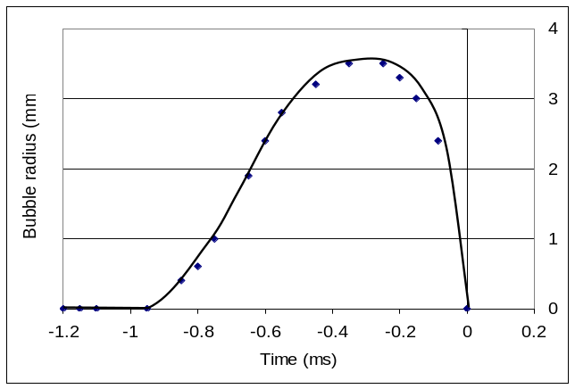  1  2  3  4  Figure 1. Graph of bubble radius as the bubble forms and collapses over time. | 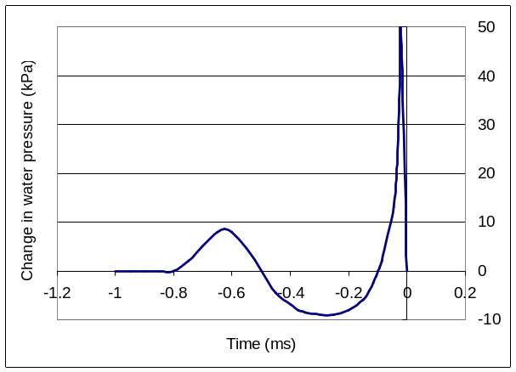  0  10  20  30  40  50  -10  Figure 2. The corresponding sound emission from the bubble, shown as pressure changes in the water over time.

Noise production
- Estimate the resonant frequency for spherical water bubbles with a radius of 3 mm. Assume a normal pressure of 100 kPa, and that the density of water is 1000 kg m⁻³.
[3 marks]

Boat propellers
- (i) When boat propellers turn, the velocity of water relative to the blades can be assumed to be the same as the speed of the blades. For boat propellers rotating at 300 revolutions per minute, at what distance along the blades from the centre of rotation might you expect cavitation bubbles to start forming?
[3 marks]

(ii) What part of boat propeller blades are most likely to suffer damage if cavitation occurs?
[1 mark]

Question 22 cont.
Snapping shrimp
- (i) What is the approximate size of the bubble created by the shrimp’s claw?
[1 mark]

(ii) How long does it take for a bubble generated by a shrimp to collapse?
[1 mark]

Question 23

The Compton Effect
(Paragraph 1)
The Compton effect is one of the more remarkable discoveries in modern physics. Young had shown that light could be diffracted, which convinced everyone that this was the end of the controversy about whether light was a wave or consisted of particles, as contended by Newton. In this context, the Compton effect was quite unexpected, and it made it necessary to revise the theories of electromagnetic radiation.

(Paragraph 2)
It was well known that particles such as electrons have a momentum given by p = mv. In the development of his theory of relativity, Albert Einstein found it necessary to assign to photons a momentum given by 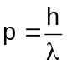, where h is Planck’s constant and λ is the wavelength of the photon. This is something that Young had never anticipated. Experiments confirmed that this relationship is true.

(Paragraph 3)
One of the applications of this property is in the phenomenon of Compton scattering. In this process, a photon collides with a stationary electron, after which the electron and the photon fly off in different directions. One of the laws of physics is that momentum has to be conserved. When you consider the momentum in both the x and the y directions, there are constraints on the final directions the scattered electron and photon can go. In addition, the total energy of the electron and the photon has to be the same before and after the collision. Putting this all together, it comes out that
electron
λ
λ′
θ
Compton scattering
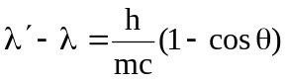

where: λ is the wavelength of the incident photon; λ′ is the wavelength of the scattered photon;
h is Planck’s constant; m is the mass of the electron; c is the velocity of light; and θ is the angle at which the photon is scattered.

(Paragraph 4)
The equation shows that the photon loses energy in the scattering process, and that the larger the angle of scatter, the greater the energy loss.

(Paragraph 5)
This discovery that photons have momentum has some rather interesting consequences. One is that photons reflected from a surface create a force on the surface. One of the more imaginative proposals that has been made is to construct giant solar sailboats with huge sails, that could be used to assist travel in the solar system. There are some technical difficulties, but one of the great advantages of such a sailboat is that the Sun provides the driving force and no fuel is necessary.

- Explain why reflection of photons from a surface should exert a force on the surface (Paragraph 5). Show in a diagram the direction of the force on the sail of a solar sailboat.
[4 marks]

- Does Compton scattering demonstrate the wave nature or the particle nature of radiation? Justify your answer.
[2 marks]

- Verify that the units for the momentum of a photon and an electron are consistent.
[3 marks]

Question 23 cont.
- (i) Which will have the higher momentum, an ultraviolet photon or an X-ray photon? State your reason.
[2 marks]

(ii) Calculate the momentum of a photon with an energy of 110 keV.
[3 marks]

(iii) Through what angle must a photon be scattered in order for it to have the lowest possible amount of energy after it is scattered? Justify your answer.
[2 marks]

- A photon with an energy of 1.76 × 10⁻¹⁴ J is scattered at an angle of 60°. Calculate the energy of the scattered electron.
[3 marks]

THIS PAGE HAS BEEN LEFT BLANK INTENTIONALLY

YOU MAY USE IT FOR PLANNING

ACKNOWLEDGEMENTS

SECTION 1

Question 12 Diagram adapted from: Giancoli, D.C. (1995). Physics: principles with applications (4th ed.) Englewood Cliffs NJ: Prentice Hall.

Question 17 Graph from: Walker, J.S. (2004). Physics (2nd ed.). Upper Saddle River NJ: Pearson Education, p. 1042.

SECTION 3

Question 22 Adapted from: Lohse, D. (2003, February). Bubble puzzles. Physics Today, pp. 38-42. Retrieved March, 2008, from: http://www.physicstoday.org/pt/vol-56/iss-2/p36.html.

Published by the Curriculum Council of Western Australia
27 Walters Drive
OSBORNE PARK WA 6017

